Workplace Adjustments Service
Quick Guide
Workplace Adjustments Service Quick Guide
This guide provides information for CUH employees to request and complete an application to the Workplace Adjustments Service. The service is available to staff who have a disability, impairment, long term or fluctuating health condition or are neurodivergent and require physical solutions to support them in their role at work.

What is a disability?
Under the Equality Act 2010, someone is ‘disabled’ if they have a physical or mental impairment that has a ‘substantial’ and ‘long term’ negative impact on their ability to do normal daily activities. This includes visible and invisible disabilities, physical and mental health conditions and neurodivergences that last or are expected to last longer than 12 months, including those that are recurring or fluctuating. There are a limited number of medical conditions (cancer, HIV, multiple sclerosis) with which an individual meets the definition of disability from the time of diagnosis. In all other situations, it is the degree of impact of the condition on day to day activities which determines whether the individual is “disabled” rather than the diagnosis.
Reasonable adjustments and the Workplace Adjustment Service
Employers have a legal duty to make ‘reasonable adjustments’ to ensure staff with disabilities are not substantially disadvantaged when doing their jobs. The Workplace Adjustment Fund is available to cover the cost and procurement of equipment. Please see the full guidance for more information and examples of workplace adjustments. Please note, this service is for physical equipment/adaptations and not for modifications to working hours or duties.
In regards to Neurodivergence it is important that the correct service referral is completed to ensure the appropriate support and services are accessed.
The Workplace Adjustment Service is able to commission Workplace Needs Assessments for members of staff who have been assessed to have a form of neurodiversity or think that they may have. These are not diagnostic assessments, they aim to provide advice and support to assist with difficulties at work arising from neurodiversity. It is not necessary to have a diagnosis to access this assessment or support.
If a member of staff would like to access a diagnostic assessment or medication (for example for ADHD) they should do so through NHS channels and processes.
This service is unable to fast track applications.

Applying for Workplace Adjustment Funding
- If you feel you require additional support at work, if possible and appropriate, have an initial discussion with your Line Manger to identify what workplace adjustments are needed, the Purple Passport can support this conversation.

Please note, identifying workplace adjustments is a process and support is available from both Oh (Occupational Health) and the Equality, Diversity and Inclusion Team.

- Complete a Request form available to download from Merlin.

- Email the application to cuh.workplaceadjustments@nhs.net

- The application will be reviewed by the Workplace Adjustments Team at Oh (Occupational health) and further steps advised.

- Depending upon the level and need and cost of support required, the Workplace Adjustments Team may suggest a referral to Access to Work. Access to work can support the organisation with additional funding for equipment or services. Further information and contact details can be found; Access to Work

- The Workplace Adjustments Team will provide correspondence regarding applications and updates when the equipment, service or software is available.

- Once the assessed support/equipment has been provided/implemented, the Workplace Adjustments Team will complete 2 reviews throughout the following year to ensure the adjustments continue to meet the need of the individual.

- All equipment purchased will be catalogued and remains the property of Oh (Occupational Health) and must be returned once it is no longer needed or if the individual leaves the organisation.

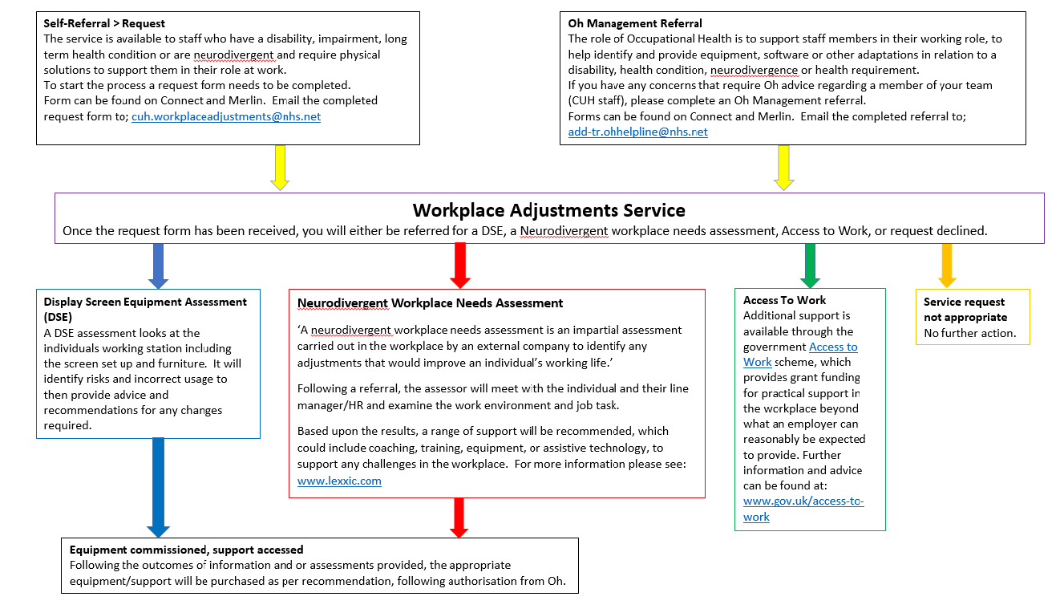

Workplace Adjustments Service Request Form

Please note that this request form is for physical equipment/adaptations and NOT for modifications to working hours or duties.
This form is CONFIDENTIAL and will only be shared with those who need to advise and process the request and third parties with your consent.
Please complete ALL fields before submitting
First Name: | Surname:
Date of Birth: | NHS Number:
Job title: | Work Email:
Electronic Staff Record number: | Division and Department:
Line Manager: | Line Manager Email:
Box Number: | HR Room Number:
Details of how a workplace adjustment would support you in your role at work;
How does your impairment or condition impact on your working day? What solutions would ease and support your condition at work? How will the adjustment support you in your role? *Please include Working from Home ratio if applicable.*

Have you completed a Display Screen Equipment (DSE) checklist?
http://merlin/Lists/DMSRecords/DispRecordTabsDoc.aspx?ID=19520
If you have completed a DSE, please submit completed checklist to: cuh.workplaceadjustments@nhs.net
If you have not completed a DSE checklist and it is relevant to your role, please complete the assessment and submit, prior to any further actions.
Is your ESR record up to date with your disability or condition? Yes ☐ No ☐
https://my.esr.nhs.uk/
Please note this does not affect your eligibility/application for adjustments.

Professional Recommendation
If your request is linked to an Oh referral or another health professional recommendation please complete the following information;
OH ☐ GP ☐ Specialist ☐ Other ☐………………………………….

Date of recommendation: …………………………………..
Additional supporting information;

Communication and Line Managers Support
Line Managers have a Duty of Care to those in their teams and this includes supporting reasonable adjustments as required. It is therefore important your line manager has an awareness of your circumstances and this request (if this at all possible).
You might want to use the Purple Passport as a tool to support a conversation with your manager.
If for any reason you do not feel able to discuss this with your manager please contact the Equality, Diversity and Inclusion Team and they will endeavour to support you; cuh.equality@nhs.net
Name of line Manager: ……………………………………………………………………….
Date of discussion/request: …… …………………………………………………………….
Manager in support of application: Yes ☐ No ☐
If you have answered no, please provide your managers reason for not supporting your application:
…………………………………………………………………………………………………………………………...
……………………………………………………………………………………………………………………………
For Information, the outcome of the application will be shared with your manager.

Consent to sharing information
I understand that my details will be stored on a centralised computer system within Oh. ☐
I consent to sharing my information, understanding that Data Protection Principles will be followed and adhered to in my application for a Workplace Adjustment. ☐
I understand information will be shared with Oh, Workplace Adjustments Panel and Third parties (with consent) in support of the application. ☐

Should you have any questions or concerns please contact cuh.workplaceadjustments@nhs.net

Signature of applicant: …………………………………………………………………………..

For your information;
In addition to Oh (Occupational Health) providing support, depending upon the cost and type of provision(s) required an application to Access to Work may be necessary and may also be beneficial linking into additional resources.
‘Access to Work can help you get or stay in work if you have a physical or mental health condition or disability. The support you get will depend on your needs’.

Eligibility
As part of Access to Work, you may be eligible for:
- a grant to help pay for practical support with your work
- advice about managing your mental health at work
For these types of support, you must:
- have a physical or mental health condition or disability that means you need support to do your job or get to and from work
- be 16 or over
- be in paid work (or be about to start or return to paid work in the next 12 weeks)
- live and work (or be about to start or return to work) in England, Scotland or Wales - there’s a different system in Northern Ireland
(https://www.gov.uk/access-to-work January 2022)

