**CONFIDENTIAL**

**Physiotherapy Self-Referral Form**

**Occupational Health Physiotherapy is available for Cambridge University Hospitals (CUH) employees off work or struggling at work with a musculoskeletal problem. If your problem does not affect you at work, please contact your local physiotherapy department.**

You must be an actual employee of CUH to be eligible for the Occupational Health or Physiotherapy service. If you are based on the hospital site but are employed by a third party, eg social services, discharge services, etc, you **will not be eligible** to self-refer.

Please complete this pre-assessment questionnaire and forward it to oh *Occupational Health and Wellbeing*, Box 172, Cambridge University Hospitals Hills Road Cambridge CB2 0QQ or email to:

**add-tr.ohhelpline@nhs.net**

The questionnaire will be added to your confidential occupational health record.

1. **Employee details**

Name: Title:

Date of Birth:

Home Address:

Email Address:

Contact Number: Work Extension:

I am happy to be left an answerphone message *(please mark X)* **Yes**  **No**

GP Surgery:

1. **Job details**

Job Title:

Department: Are you a CUH employee? **Yes**  **No**

*If no, you are not eligible for this service.*

1. **Appointment arrangements**

Where applicable please indicate where the *Occupational Health and Wellbeing* appointment details should be sent:

(i) Home

(ii) Work

(iii) Appointment date already confirmed

*Note: Ordinarily, self-referrals will not result in written reports to anyone. If you are seeking written recommendations from oh Occupational Health to your manager, please ask your manager to complete a written management referral.*

1. **Reason for self-referral**
2. Please provide a brief description of your symptoms:

*e.g. pain/ache/weakness/abnormal sensation, severity of symptoms, aggravating factors etc.*

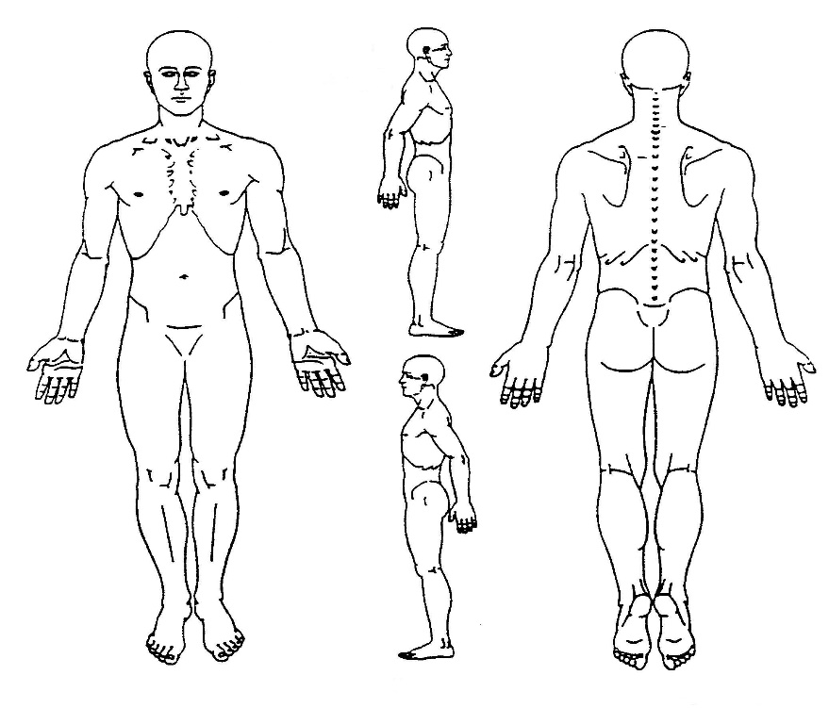

1. Please highlight the chart below to show where you experience your symptoms:
2. How long have you had this current problem for and have you experienced these symptoms before?

*If yes please provide details including any* *physiotherapy or other treatment received*

1. Are your symptoms IMPROVING / WORSENING / STAYING THE SAME *(delete as necessary)*
2. Have you consulted your GP about this problem? *(please mark X)* **Yes**  **No**
3. How is the problem affecting you at work?
4. Have you been signed off work or taken sick leave for this issue within the last 6 months?

*If so please give details of estimated dates and time periods.*

1. What outcomes are you hoping to achieve?

**Signature: Date:**